**Exploring Distribution of House Price Palette with Tableau**

**Problem Statement:**

ABC Company aims to optimize its market presence and sales performance in the housing sector by gaining insights into the distribution of house prices based on count of prices. The management seeks to understand the concentration of properties within different price ranges across various regions to tailor marketing strategies and pricing models effectively. By analyzing the distribution of house prices, ABC Company aims to identify key market segments, develop targeted approaches to address customer preferences, and enhance its competitive edge in the housing market.

**Prerequisites:**

* Basic understanding of Data Analytics

[What Is Data Analytics? - An Introduction (Full Guide)](https://youtu.be/yZvFH7B6gKI?si=jD37tQzKJH1vl56A)

* Awareness of the lifecycle of a Data Analytics Project

[A Beginners Guide To The Data Analysis Process](https://youtu.be/lgCNTuLBMK4?si=a_J79oNSQIGNuNlH)

* Understand Tableau Interface- [Link](https://www.youtube.com/watch?v=oIw8xJ1Fy3w)
* Download Tableau Desktop-[Link](https://www.tableau.com/products/desktop/download)

**Objective:**

An objective is a specific, measurable, and time-bound goal or target that an individual or organization aims to achieve. Objectives are typically set to guide actions and decision-making towards desired outcomes. They are often a part of broader goals and help to clarify what needs to be accomplished within a certain timeframe. Objectives should be realistic, achievable, and relevant to the overall mission or purpose, providing a clear direction for efforts and resources.

**Task:**

* Analyze the distribution of house prices based on count of prices to identify key market segments and understand the concentration of properties within different price ranges across various regions.
* Develop tailored marketing strategies and pricing models based on insights derived from the distribution of house prices to optimize market presence and sales performance in the housing sector.

**Dataset**: [Link](https://github.com/mochen862/king-county-house-sales)

**Solution Development Procedure:**

* In Tableau, the "Connect" option refers to the initial step in the data visualization process where users connect to various data sources to import data into Tableau for analysis and visualization.
* When you select the "Connect" option in Tableau, you are presented with a variety of data connection options.

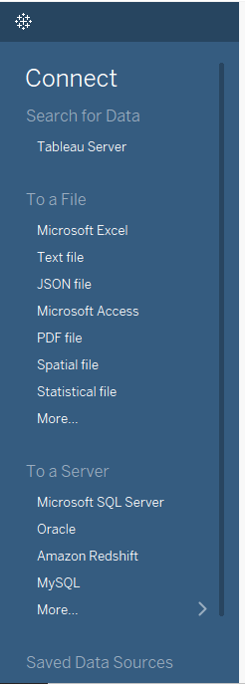

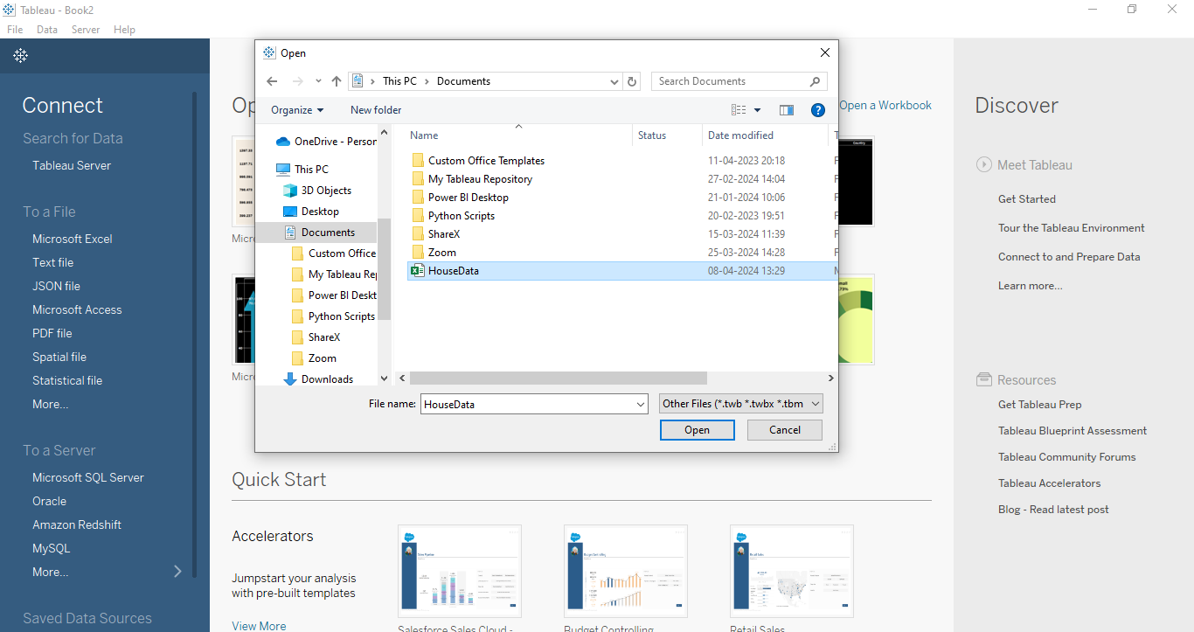

* Once we load the data into the Tableau.

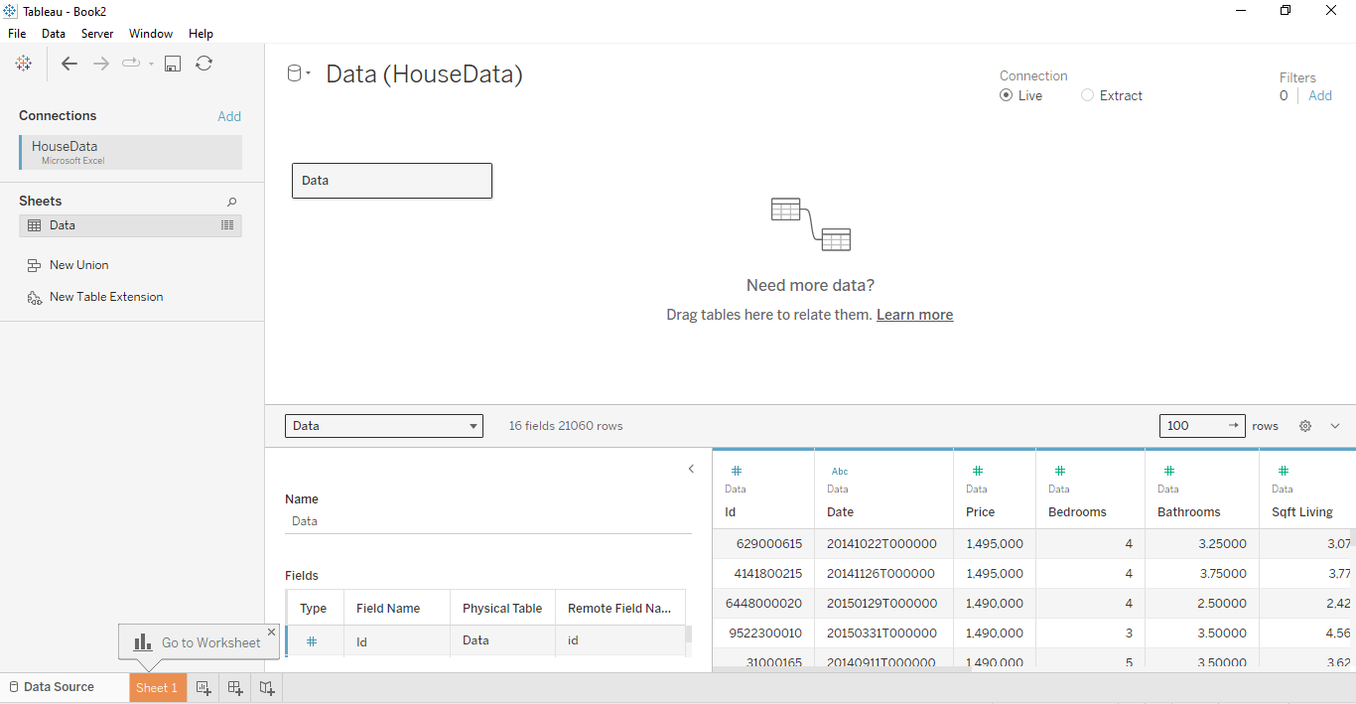

* Click on Price and click on “show me” to display the visuals according to the measure.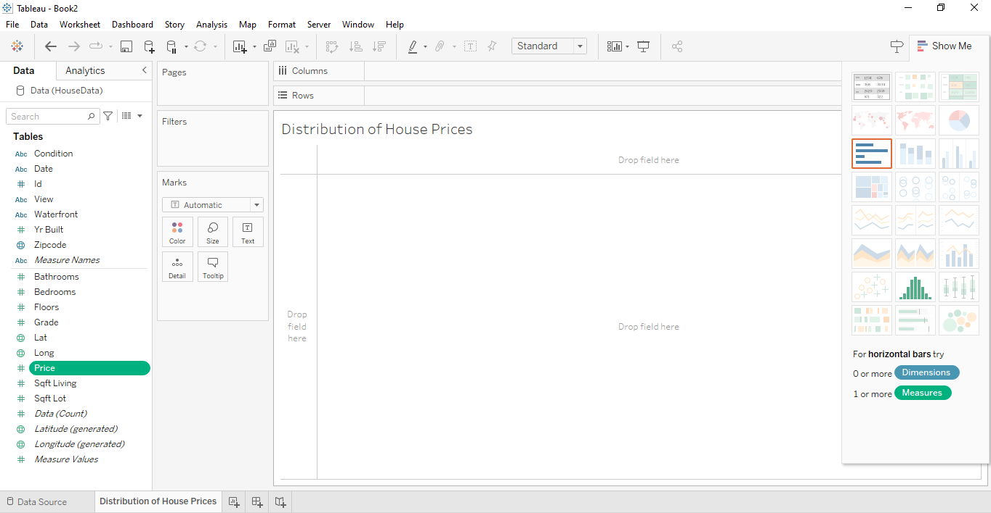
* Click on Histogram, where you can observe the columns with Price(bin) and rows with Count of Price.

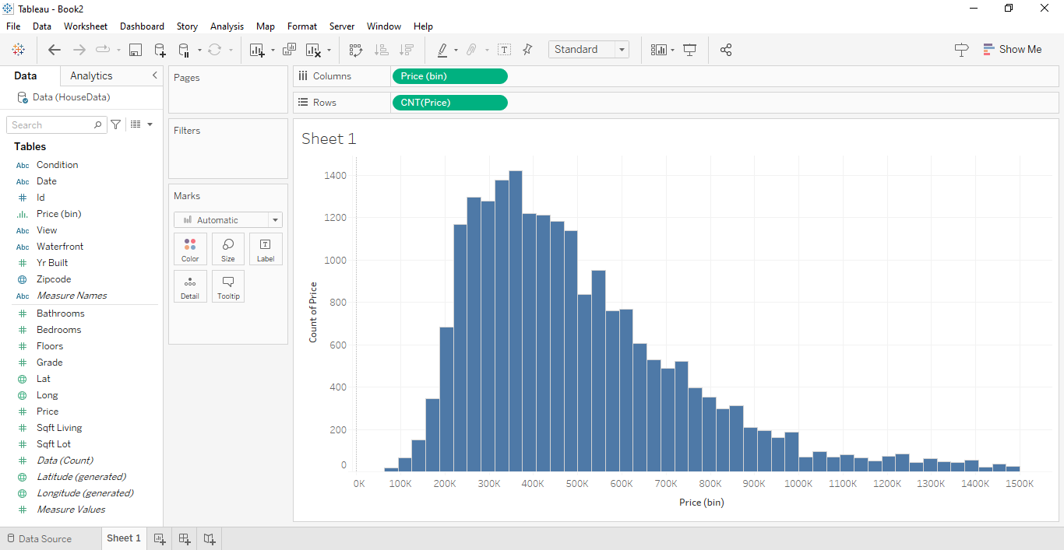

* Drag Count of Price into the Label to display on Histogram.

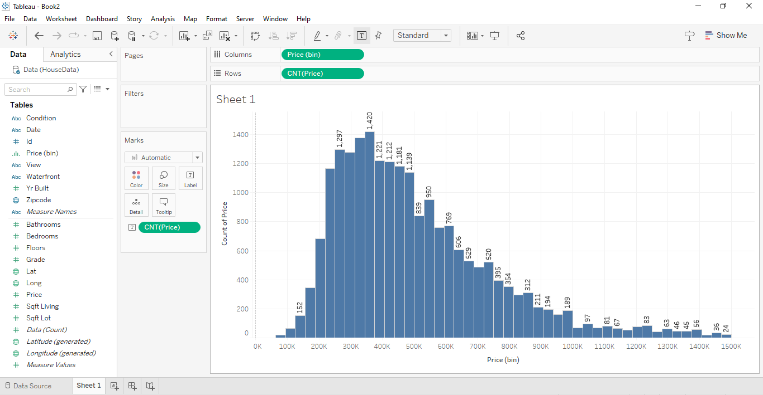

* Change the Colour of your Histogram and to display the data labels all over the Histogram, Change the size of bins.

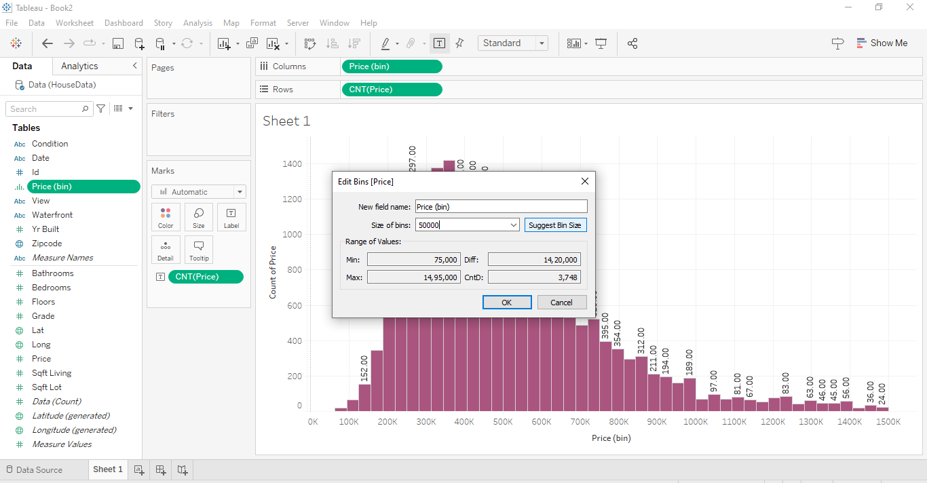

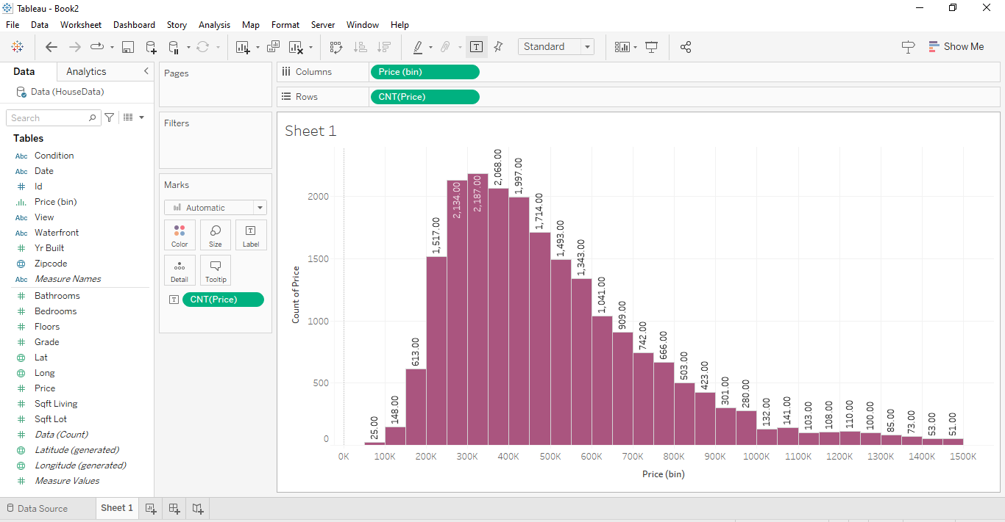

* Set up Quick Table Calculation to Percent of Total.

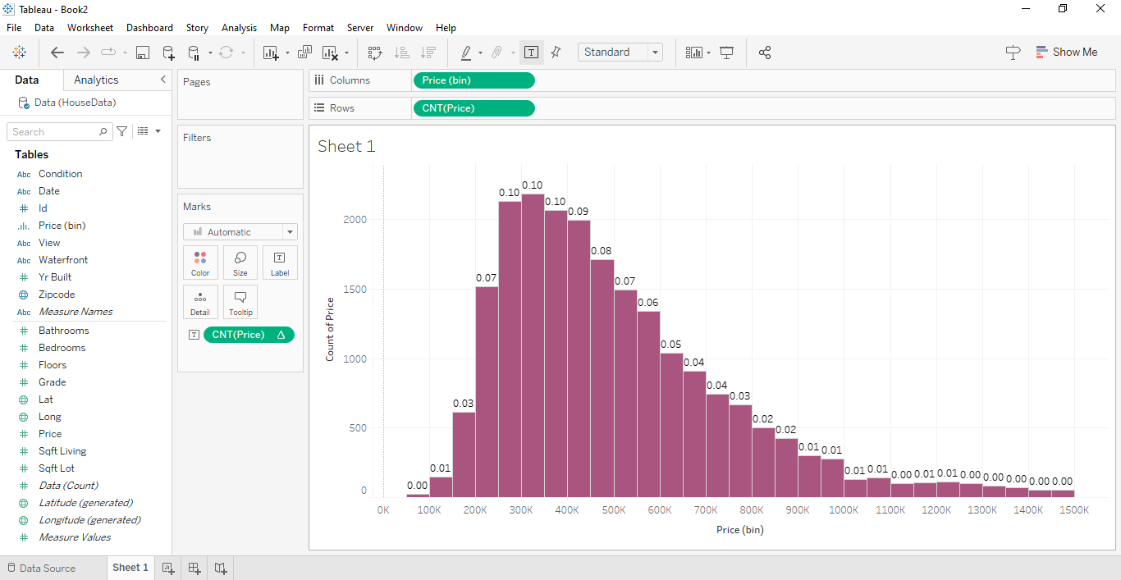

* Set up the Decimal values places in Format section and also change the Percentage values to display above the Histogram.

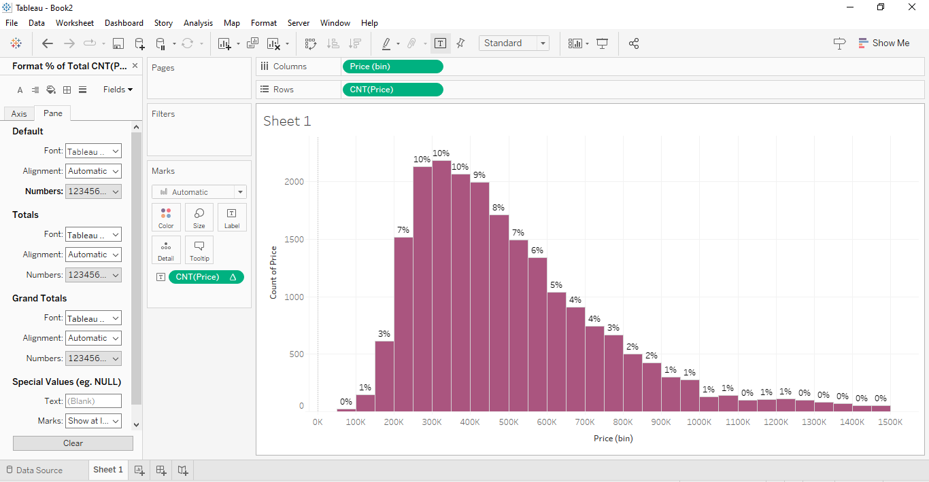

* Set up the Title and Format your Colour, Background and Shading.

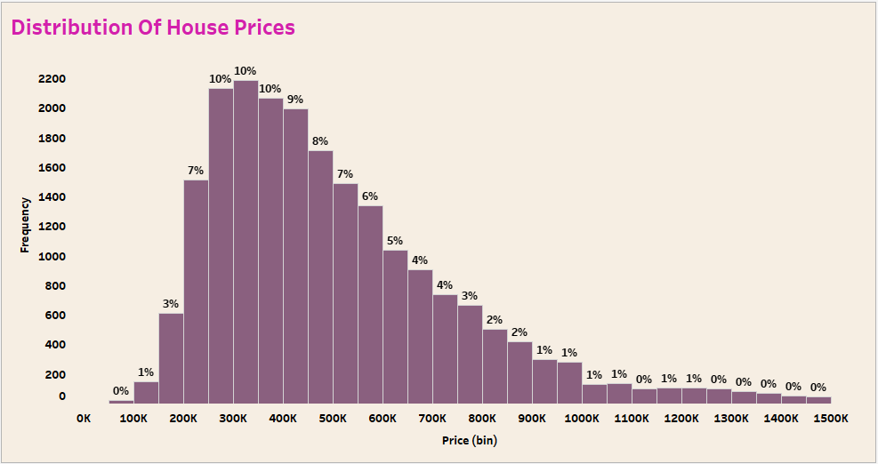

**Insights:**

Insights refer to valuable and meaningful understandings or perceptions gained from analyzing data, information, or experiences. They provide deeper understanding, clarity, or revelation regarding a particular subject or situation.

* The distribution of house prices based on count reveals distinct peaks or clusters within certain price ranges, indicating market segmentation and varying levels of affordability.
* Understanding these distribution patterns can assist in identifying market segments with different housing preferences and purchasing power, allowing for targeted marketing strategies and product offerings tailored to specific price brackets.
* Analysis of the distribution of house prices based on count provides insights into the overall demand and supply dynamics within the housing market, guiding decisions related to pricing strategies, inventory management, and market positioning.

**Conclusions:**

Conclusions are logical deductions or decisions drawn from observations, evidence, or analysis. Conclusions are often based on the findings or results of a study, experiment, or evaluation, and they aim to summarize key insights or outcomes. Effective conclusions should be supported by evidence, logical reasoning, and critical thinking, leading to well-informed decisions or actions.

* The analysis of the distribution of house prices based on count of prices has unveiled distinct patterns within the housing market, indicating concentrations of properties across different price ranges.
* These findings offer valuable insights for stakeholders in the housing sector, enabling them to understand market segmentation and tailor their strategies accordingly to meet the varying demands and preferences of customers.
* Leveraging these insights can empower decision-makers to optimize resource allocation, refine marketing efforts, and enhance overall market performance by strategically addressing the needs of different price segments within the housing market.